Stephen Hawking Facts
Born 1942 Died 1918 Aged 76
Stephen Hawking has been one of the most famous scientists of modern times.
He was diagnosed with a serious illness when he was in his 20s but overcame huge physical difficulties to investigate black holes in space.
His discoveries changed the way scientists understood black hole.

- He was born on 8th January 1942. He died this week on 14th March 1918
- Steven Hawking has made many important discoveries about space..
- He wrote a best- selling book called ‘A Brief History of Time’.
- He wrote a children’s book called ‘George's Secret Key to the Universe’- perhaps you could read it!
- Steven Hawking was especially interested in black holes – try to find out about them yourself!
- Hawking’s illness left him almost completely paralyzed but he talked using a special voice box. He made the voice work by moving muscles in his face.
- He won lots of prizes for his discoveries including the Albert Einstein Medal in 1979, the Order of the British Empire in 1982 and the 1988 Wolf Prize in Physics.
Famous Stephen Hawking quotes:
“We can't predict what that will be or when we will find it because if we knew that, we would have found it already!”
“For millions of years, mankind lived just like the animals. Then something happened which unleashed . the power of our imagination. We learned to talk and we learned to listen.”
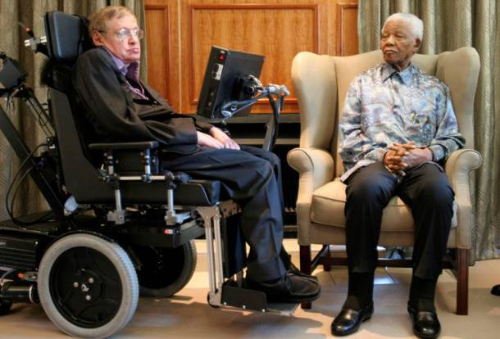
“It is a waste of time to be angry about my disability. One has to get on with life and I haven't done badly. People won't have time for you if you are always angry or complaining.”
