History- The children have come up with questions, which they would like to know about the topic, these are… Are there any castles near Ellwood? Why are castles built on hills? What did people do in castles? What are castles made from?

Castles, rivers and settlements

Geography – develop an understanding of the world around us, the countries that make up the United Kingdom, the continents and oceans that make up the world. Identifying key features on a map.

RE – children will answer the question ‘Jesus: What did he teach?’

P.E. – children will listen to instruction and develop their movement, moving in different ways changing direction and speeds.

DT– design, build and evaluate a castle

Music – listen to and respond to music.

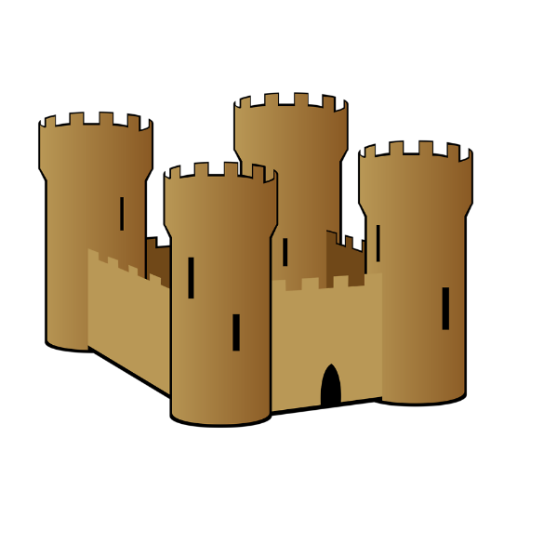

Maths – learn about place value to 50, addition and subtraction to 20, multiples of 2, 5 and 10. Recognise and name 3D and 2D shapes. Sorting shapes and making patterns.

English – become familiar with traditional stories. Write letters, stories and non-chronological reports

Art – the children will be looking at the work of Paul Klee and are going to be creating artwork in a similar style.

Science –

children will identify everyday materials and will perform simple tests to discover which materials are best to keep a ‘hollow chocolate safe’ from breaking in the post.