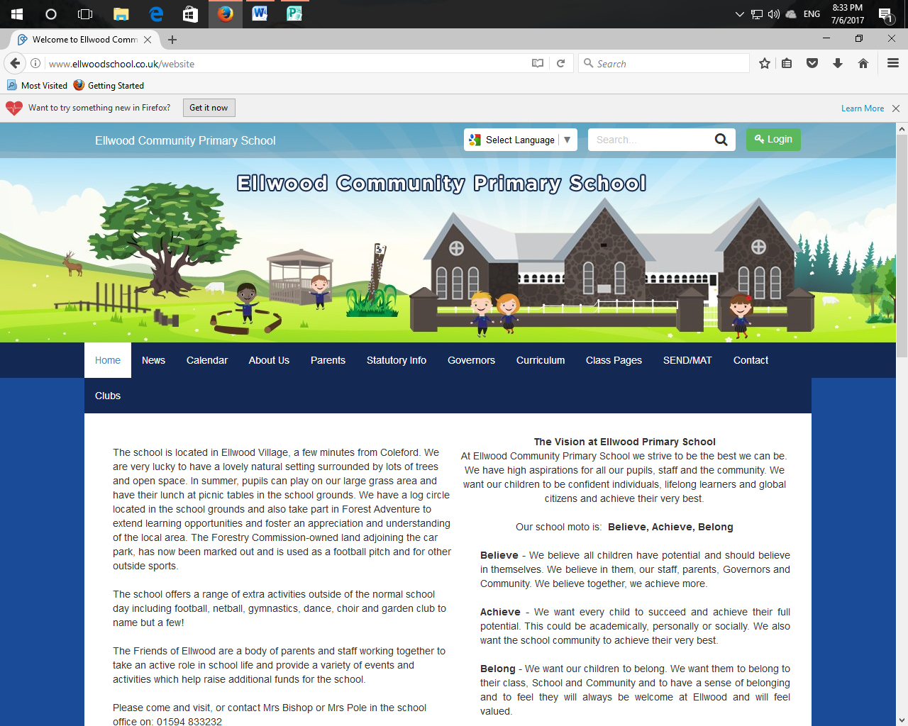 **Y4 Newsletter Summer Term 2025**

Welcome back!

We hope you have had a lovely, fun filled Easter break and are ready for the busy term ahead!

**Maths** – This term we will be continuing to learn about Decimals and Money. We will then explore Time, Shape, Statistics and Position and Direction. The children will be working to extend their fluency, reasoning and problem solving skills.

**English** – This term, the children will be exploring and basing their writing around quality texts including ‘Twitch’ by M.G. Leonard

**Times tables and number facts –** Children need to have quick recall of multiplication and division facts for the 2, 3, 4, 5, 6, 7, 8, 9 ,10, 11 and 12 times tables. TTRS is a great way to practice these at home. Your child’s logins can be found in their Reading Diary.

**Reading –** We expect children to read their levelled reading book at least four times a week at home. Please try to use the guided reading question prompt bookmark that will be sent home in your child’s reading record. It is great to aim to ask at least one question for each page of text your child reads. Please sign and comment in their reading records when you listen to them read.

**Spelling** – Pupils will learn new spelling patterns in class each week and practise them regularly. Please can you continue to practise these with your child at home (a spelling list will be sent home with your child in their homework file).

**Science -**This term the children will be learning about ‘Animals including Humans- please see attached overview for more information.

**Other areas of the Curriculum -** Please see the attached document to give you an overview of some of the other areas we will be learning about in the afternoons. If you have any resources linked to these areas that you would be happy to share please let us know.

**Homework**

Year 4’s homework will be set on a Monday and due in the following Monday.

* Children are expected to read at least 4 times a week.
* Practise spelling pattern for the week
* Practise times tables that they are working on in class
* Maths homework based on the current area they are developing
* Every other week children will have a reading comprehension activity to complete.

**Seeing teachers—**Should you have any concerns whatsoever about your child's education or wellbeing, or any questions you wish to raise, then please do not hesitate to contact me by ringing the school office. There may not always be someone to answer the phone so please leave a message and I will get back to you.

**PE-** This term children will need to wear PE kit on a Wednesday where they will be developing Athletics skills.