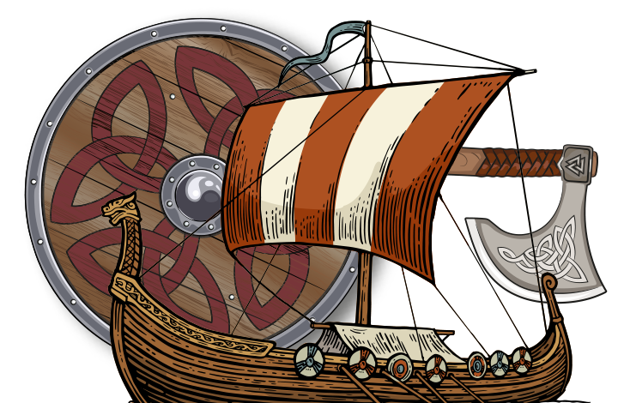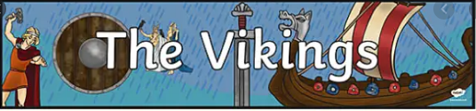

**Religious Education**

* We will be learning about Viking mythology and, in particular, their thrilling creation story
* We will be learning about the Viking Gods and Goddesses

**Sycamore Topic Web – Pupil Overview**

**English**

* We will be reading the book ‘Arthur and the Golden Rope’ by Joe Todd Stanton.
* We will be completing the following writing based on this book:
  + Character description
  + Plan, write and edit a short story
  + Diary entry
  + Persuasive letter
  + Writing in first person

**D and T/Computing**

* We will be researching the Viking board game Hnefatafl and we will be creating our own.

**History**

We will be learning how to:

* Identify who the Vikings were and where they came from
* Understand where and how the Vikings lived
* Learn about Viking homes
* Research Viking warriors

**Geography**

* We will be using a map of Europe to identify where the Vikings came from
* We will be looking at topographical features of the in the Forest of Dean and where the Vikings settled and why