**Y3 English**

x/c Y3 History: Stone Age to Iron Age Britain.

MainTexts: Stone Age Boy

* Narrative
* Newspaper Report
* Presentations

Travelling through time!

Seashore

**DT**

* Research and explore wheels and axles
* Design a caravan or food vending vehicle suitable for a coastal resort.

**Cooking and Nutrition**

* Explore local food and pioneering horticulturists in contrast to the coastal holiday regions
* Prepare & cook ‘Gloucester Pie’ safely and hygienically.

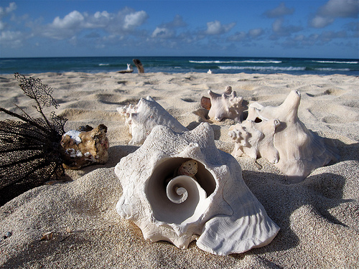

**History/ Geography**

* Use sources of evidence to find out about the past. Who was Grace Darling?
* What did Grace Darling do? How has life changed?
* Understand land use over time – lighthouses and coastal resorts.



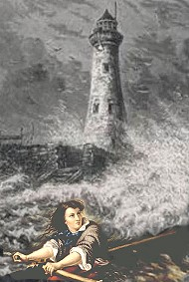

**Art and Design**

* Drawing and sketching seashells/ starfish
* Explore colour, painting seascape scenes.
* Making clay starfish sculptures.

**Y3 Science**

* Explore how light is needed in order to see. Discover more about sources of light and how light is reflected from some surfaces.
* Investigate how shadows are formed and how they change.