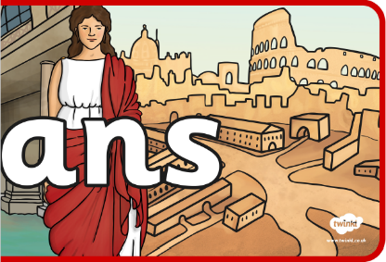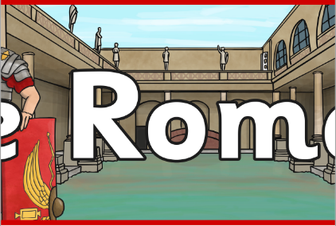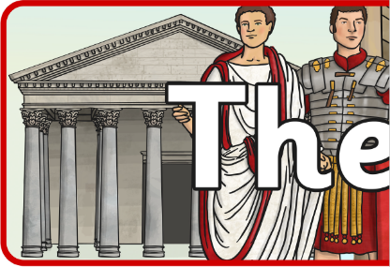

**Design and Technology**

* We will make and evaluate a Roman catapult.

**Geography**

* We will be learning about where Rome is.
* We will be learning about volcanoes when we begin to look at Pompeii.

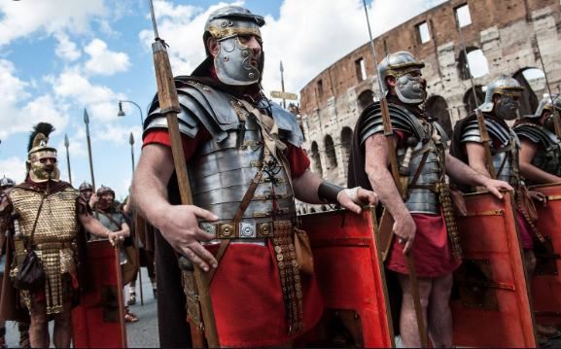

**English**

* We will be reading the book ‘Escape from Pompeii’ and looking at writing our own narrative based on this story set in Ancient Rome.
* We will be writing our own diary entries, letters and non-chronological reports based on the events of Pompeii.

**Religious Education**

* We will be learning about the Roman’s religious beliefs.

**Maths and Science**

* We will be learning how to identify and use Roman Numerals.

**History**

* We will learn about what Britain was like before it was invaded and we will learn about the Celts.
* We will learn about Claudius’s invasion.
* We will learn about Boudicca.
* We will learn about Hadrian’s Wall.
* We will learn about what it was like to be a Roman.
* We will learn about the Roman army.
* We will learn about what the Romans did for us.

**Art**

* We will be learning about mosaics and their importance.
* We will design our own mosaic and then create one using ceramic tiles.