Curriculum Overview
Beech Class HJW Spring 2/Summer Term 2018-2019 Seashore
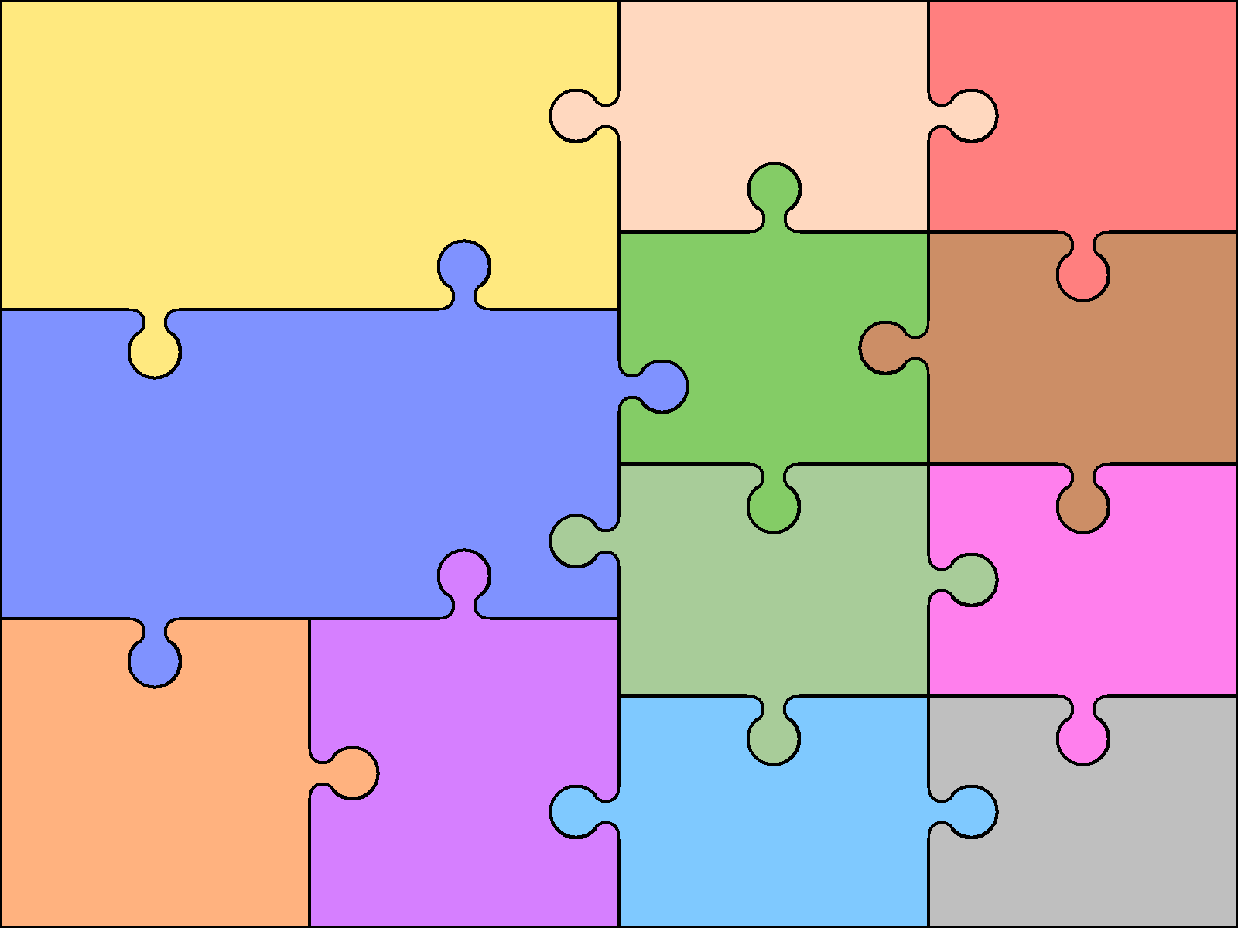  Reading  •Use knowledge to read ‘exception’ words  •Read range of fiction & non-fiction  •Use dictionaries to check meaning  •Prepare poems & plays to perform  •Check own understanding of reading  •Draw inferences & make predictions  •Retrieve & record information from non-fiction books  •Discuss reading with others | Y3 English  Writing  •Use prefixes & suffixes in spelling  •Use dictionary to confirm spellings  •Write simple dictated sentences  •Use handwriting joins appropriately  •Plan to write based on familiar forms  •Rehearse sentences orally for writing  •Use varied rich vocabulary  •Create simple settings & plot  •Assess effectiveness of own and others’ writing |  | Grammar  •Use range of conjunctions  •Use perfect tense  •Use range of nouns & pronouns  •Use time connectives  •Introduce speech punctuation  •Know language of clauses  Speaking & Listening  •Give structured descriptions  •Participate activity in conversation  •Consider & evaluate different viewpoints | Y2/3 Art & Design  - Use a range of materials  • Use drawing, painting and sculpture  • Develop techniques of colour, pattern, texture, line, shape, form and space  • Learn about range of artists, craftsmen and designers  • Use sketchbooks to collect, record and evaluate ideas  • Improve mastery of techniques such as drawing, painting and sculpture with varied materials  • Learn about great  artists, architects  & designers | Y2/3 Computing  • Understand use of algorithms  • Write & test simple programs  • Use logical reasoning to make predictions  • Organise, store, retrieve & manipulate data  • Communicate online safely and respectfully  • Recognise uses of IT outside of school  • Design & write programs to achieve specific goals, including solving problems  • Use logical reasoning  • Understand computer networks  • Use internet safely and appropriately  • Collect and present data appropriately
 |  |  |  | Y2/3 Design & Technology  • Design purposeful, functional & appealing products  • Generate, model & communicate ideas  • Use range of tools & materials to complete practical tasks  • Evaluate existing products & own ideas  • Build and improve structure & mechanisms  • Use research& criteria to develop products  which are fit for purpose  • Use annotated sketches and prototypes  to explain ideas  • Evaluate existing products and improve own work  • Use mechanical systems in own work | Y2/3 Geography  • Name & locate world’s continents and oceans  • Compare local area to a non-European country  • Use basic vocabulary to describe a less familiar area  • Use simple fieldwork and observational skills to study the immediate environment  • Locate world’s countries, focussing on Europe & Americas focus on key physical & human features  • Study a region of the UK (not local area)  • Describe & understand climate, rivers, mountains, volcanoes, earthquakes, settlements, trade links, etc.  • Use fieldwork to observe, measure & record
Number/Calculation  •Learn 3, 4 & 8x tables  •Secure place value to 100  •Mentally add & subtract units, tens or hundreds to numbers of up to 3 digits  •Written column addition & subtraction  •Solve number problems, including multiplication & simple division and missing number problems  •Use commutativity to help calculations | Y3 Mathematics  Geometry & Measures  •Measure & calculate with metric measures  •Measure simple perimeter  •Add/subtract using money in context  •Use Roman numerals up to XII; tell time  •Calculate using simple time problems  •Draw 2-d / Make 3-d shapes  •Identify and use right angles  •Identify horizontal, vertical, perpendicular and parallel lines |  | Fractions & decimals  •Use & count in tenths  •Recognise, find & write fractions  •Recognise some equivalent fractions  •Add/subtract fractions up to <1  •Order fractions with common denominator  Statistics  •Interpret bar charts & pictograms
 |  |  |  | Y2/3 Modern Languages  - Not required at KS1  • Listen & engage  • Ask & answer questions  • Speak in sentences using familiar vocabulary  • Develop appropriate pronunciation  • Show understanding of words & phrases  • Appreciate stories, songs, poems & rhymes  • Broaden vocabulary  Y2/3 PE  . Master basic movement, e.g. running, jumping, throwing catching, balance, agility and co-ordination  . Participate in team games  • Use running, jumping, catching and throwing in isolation and in combination  • Play competitive games, modified as appropriate  • Develop flexibility & control in gym & athletics  • Compare performances to achieve personal bests  • Swimming proficiency at 25m (KS1 or KS2) | Y2/3 Music  • Listen & understand live and recorded music  • Make and combine sounds musically  • Play tuned & untuned instruments musically  • Improvise & compose music  • Listen with attention to detail  • Appreciate wide range of live & recorded music  Y2/3 RS Y2/3 PSHCE  Theme:  Easter – Forgiveness  Theme:  Hindu Beliefs  Judaism Beliefs
Y2/3 Science  Chemistry  •Identify and compare uses of different materials  •Compare how things move on different surfaces  •Classification of rock types  •Simple understanding of fossilisation  Physics  •Sources of light; shadows & reflections  •Simple forces, including magnetism |  | Y2/3 History  •Changes in living memory (linked to aspects of national life where appropriate)  •Significant local people  - Local History Study – compare Forest of Dean to the coast  .  - British History (taught chronologically)  Stone Age to Iron Age Britain, including:  - hunter-gatherers and early farmers – Bronze age religion, technology & travel – Iron age hill forts

