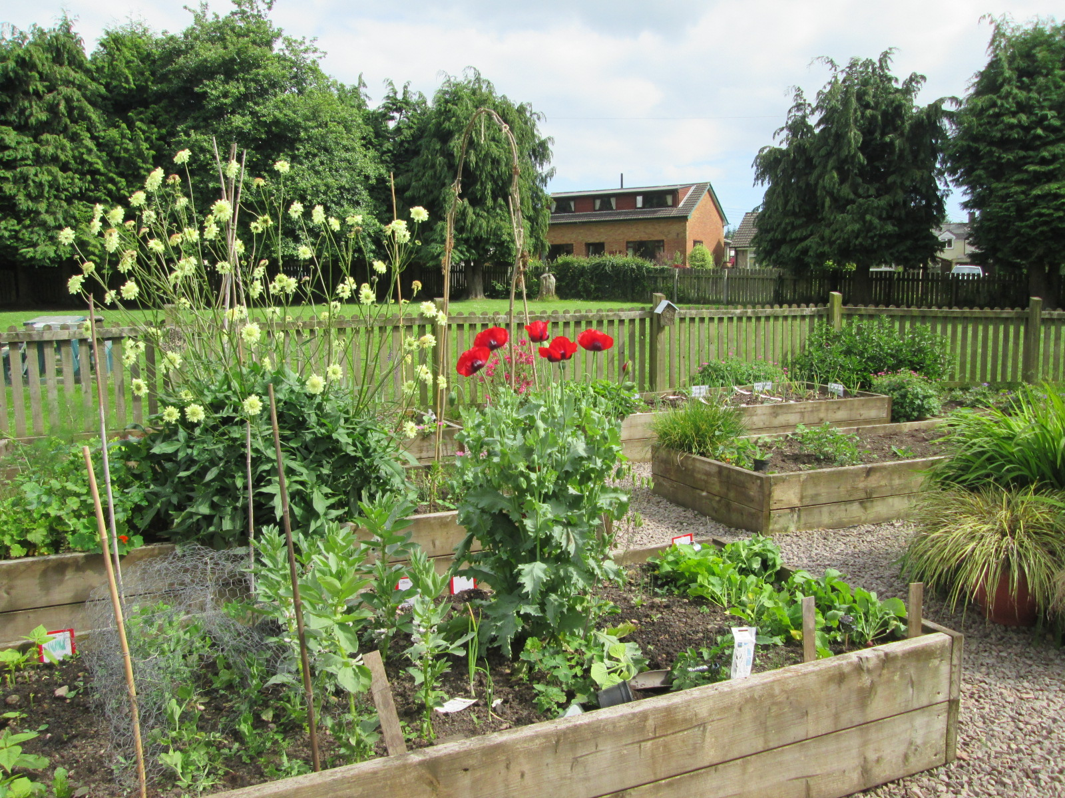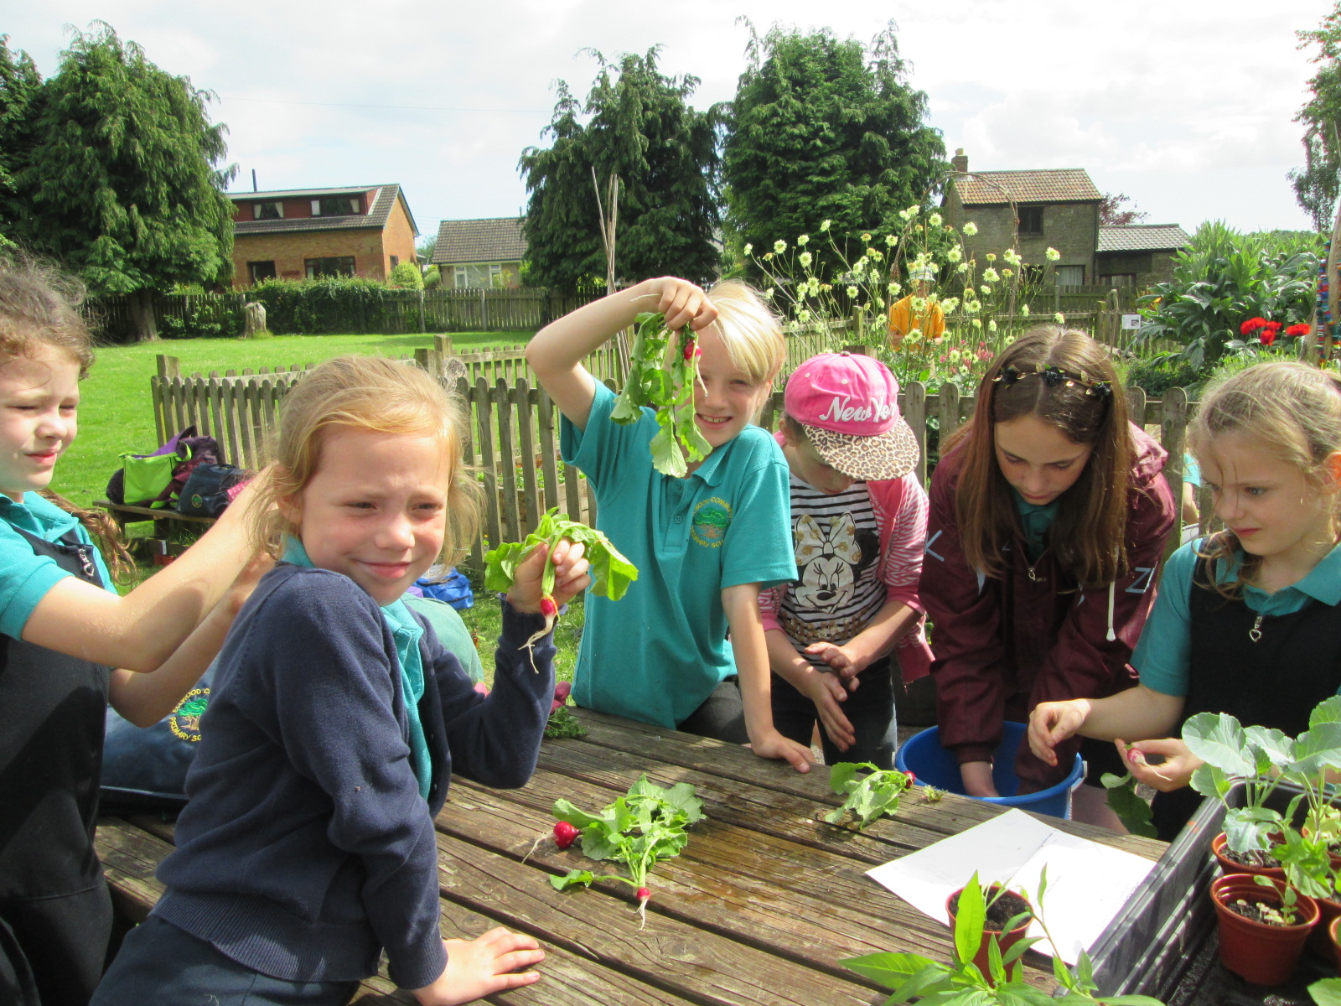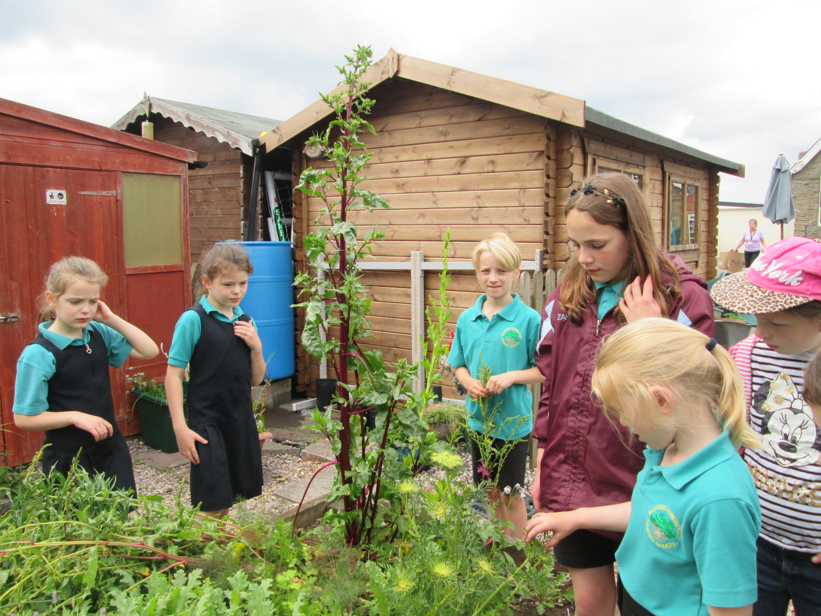 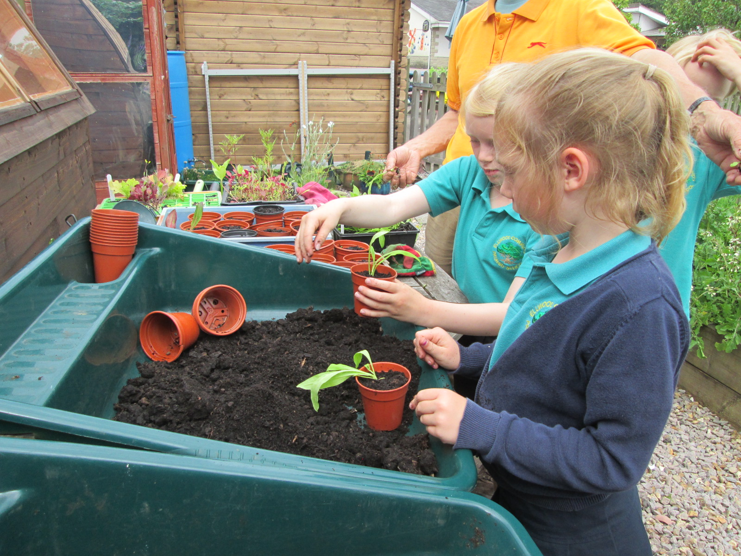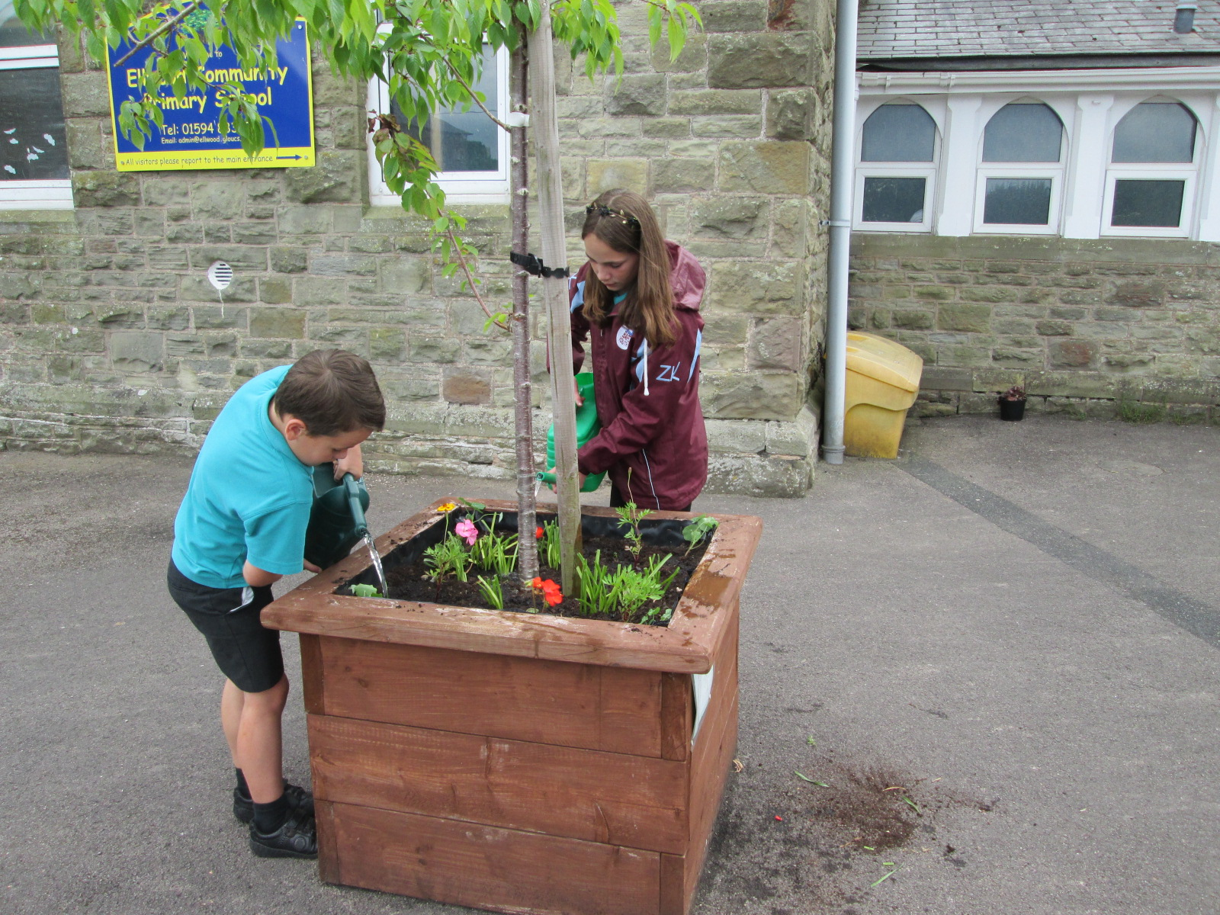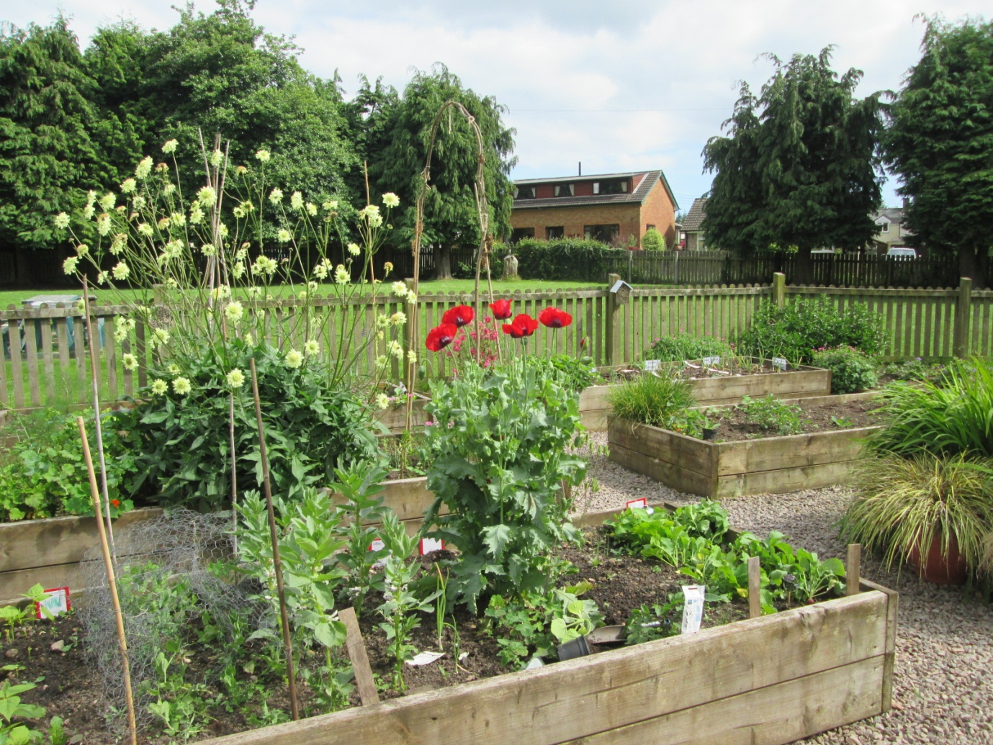

Garden Club with our radishes.

June 2017

We left a beetroot and carrot go to seed. We predicted what colour the flowers would be.

We pricked out and potted up the seeds we planted.

Garden Club planted up the tubs with plants we have grown. Here they are being watered in.

Sycamore Class researched what plants attract bees and we planted them.

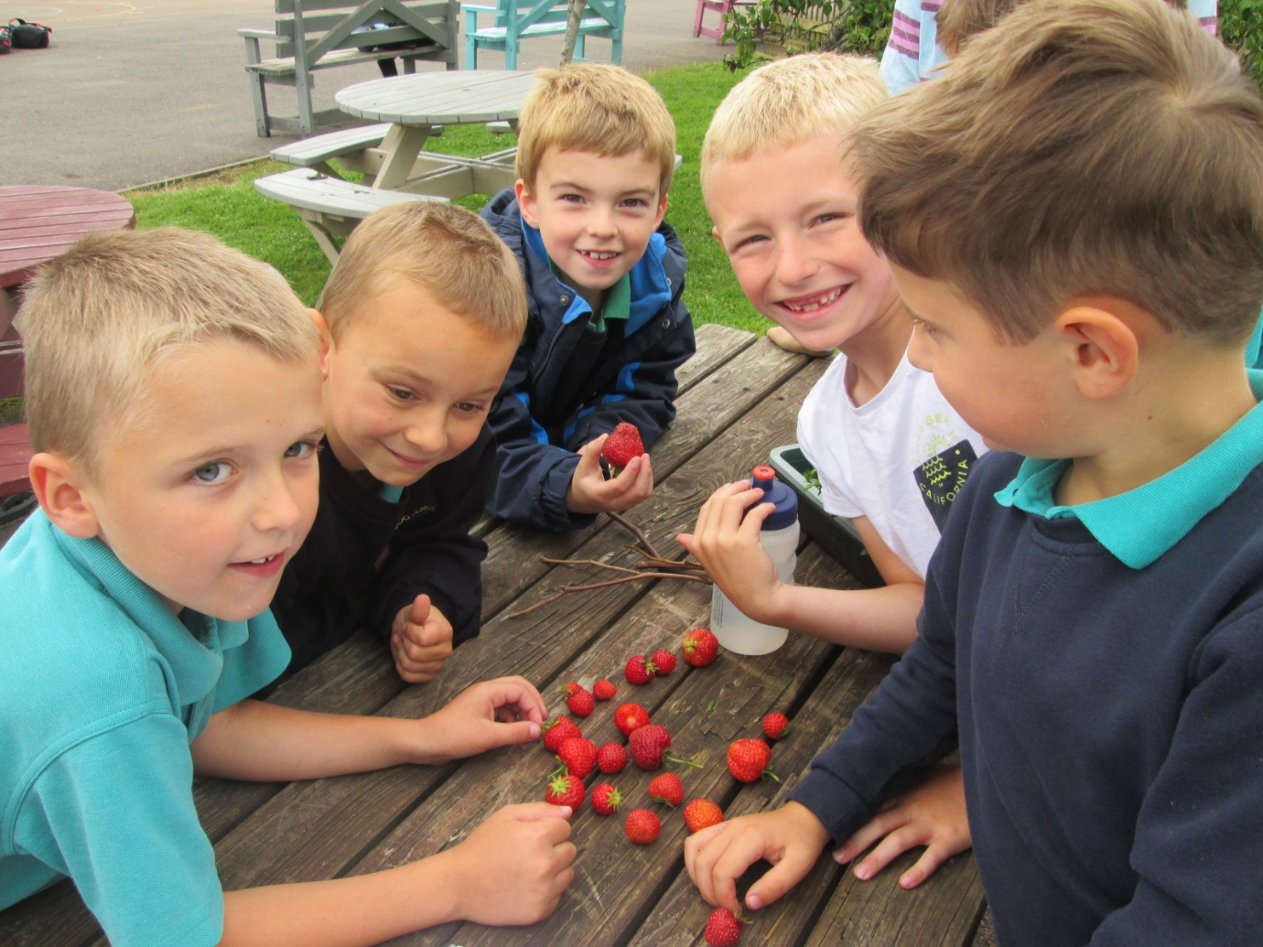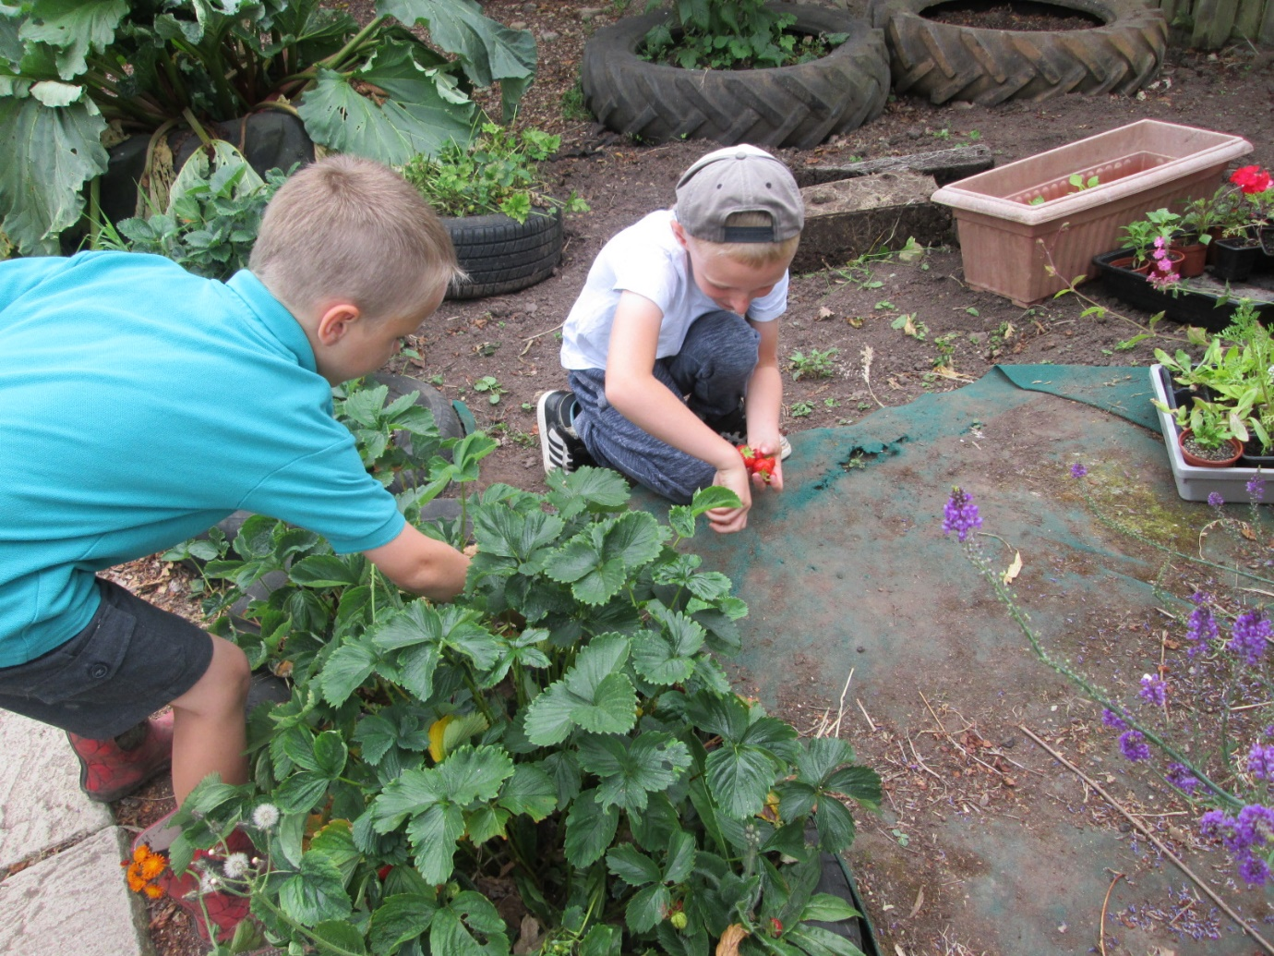

Picking and eating strawberries is a highlight of our summer Garden Club.