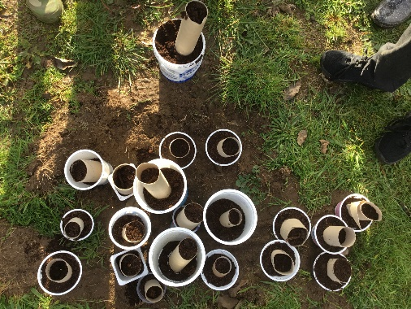  Planting acorns with Forestry England | 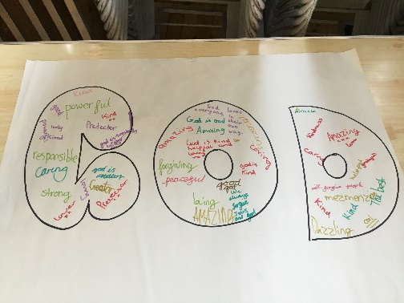  Prayer Spaces workshop | 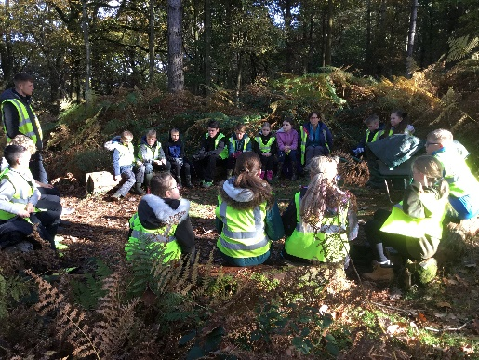  Forest Adventure fun | 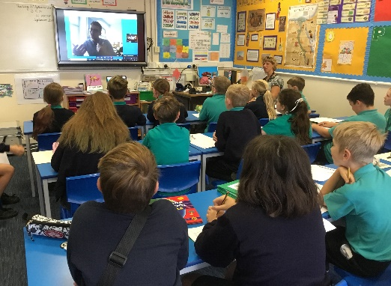  Skyping Jake in Germany as part of  our German topic
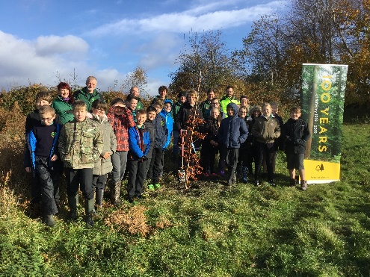  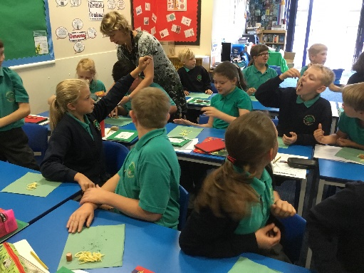  Tasting German food as part of our European Day of Languages celebrations | Willow Class  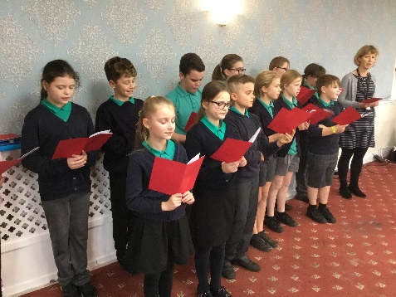  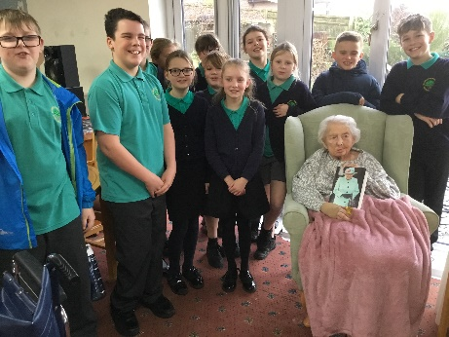  2019-2020 |  | 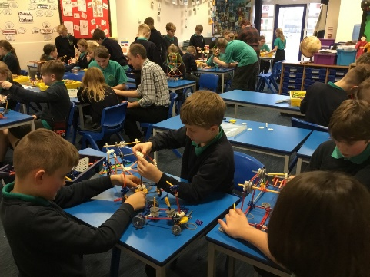  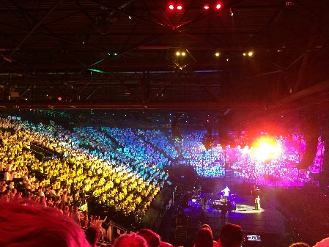  This year the K’nex challenge was to design a carnival float
Marking Remembrance and the centenary of Forestry England | Meeting a 100 year old lady and singing carols  at The Elms care home |  |  | Young Voices at Birmingham

