**A group of Year 5 children were given the job of creating a banner showing our 6 core values for our school hall. We had 5 fabulous afternoons of creativity!**

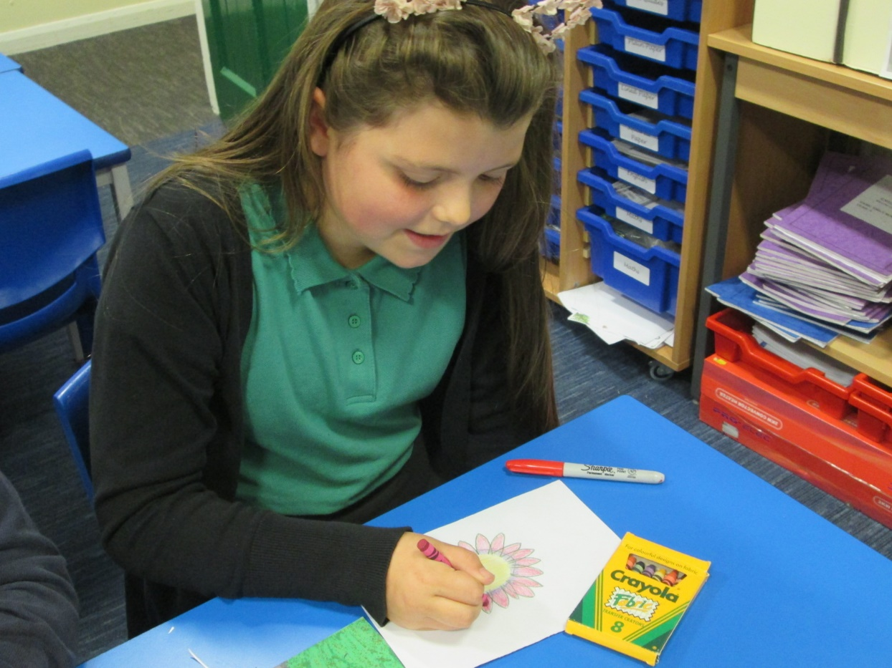 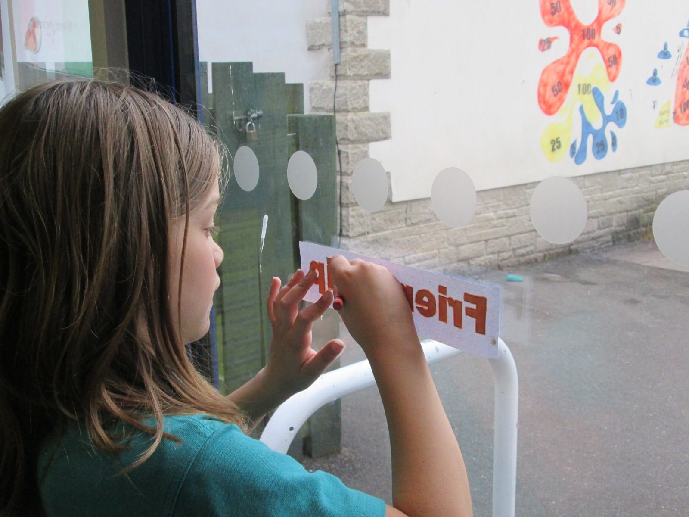

We also created flowers and leaves with the transfer crayons.

The children used the computer to choose a font they liked. Then we attached to the window so that we could colour with transfer crayons on the back. We did this because when we ironed the crayon it flips over making a mirror image.

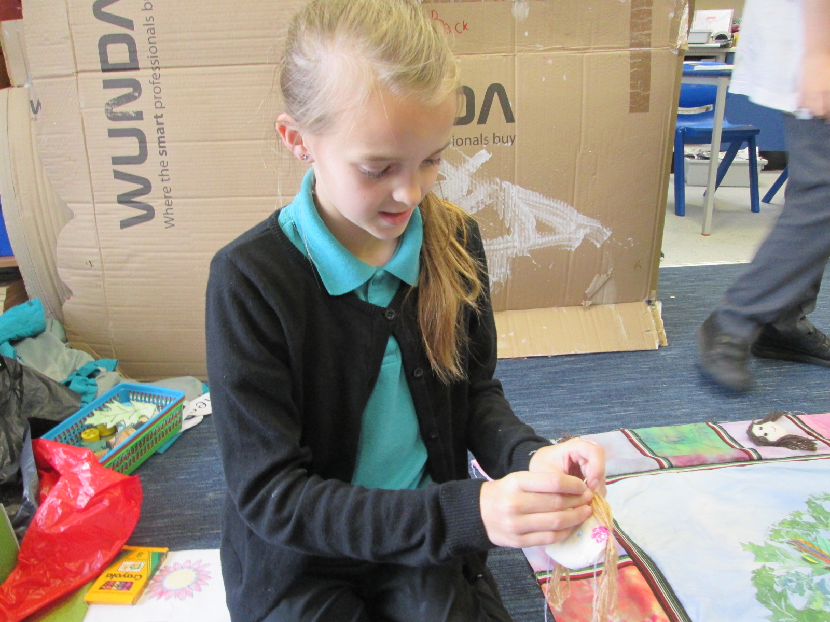

We spent one afternoon creating our own faces. Everyone learnt new skills and felt a great deal of pride with their achievements.

Part of our first session involved tie dying and space dying the edge fabric. We tried lots of different techniques. Sadly Mrs Rees forgot to take photos as we were trying not to dye our clothes and were having too much fun!

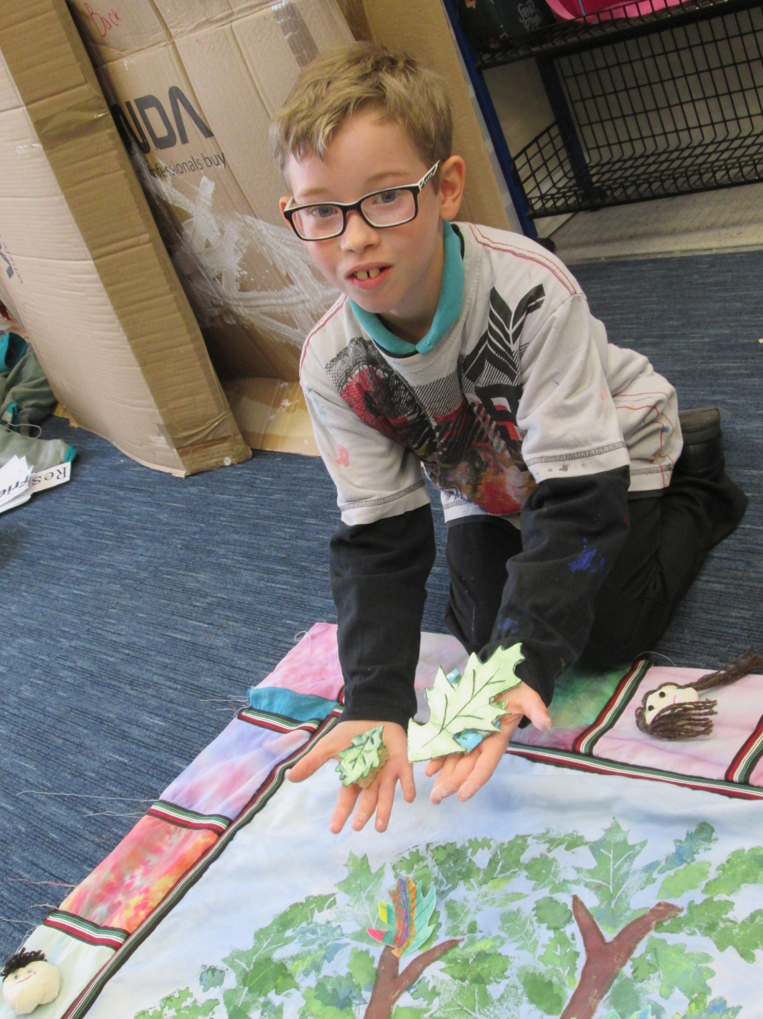

We made our own printing blocks using polystyrene. These were used to print on the leaves of the tree and we also made some flowers. We applied the blue, yellow and green paint with the dabbing of a small sponge. This gave us more shades of green. Extra leaves were added using printed fabric and transfer crayons.

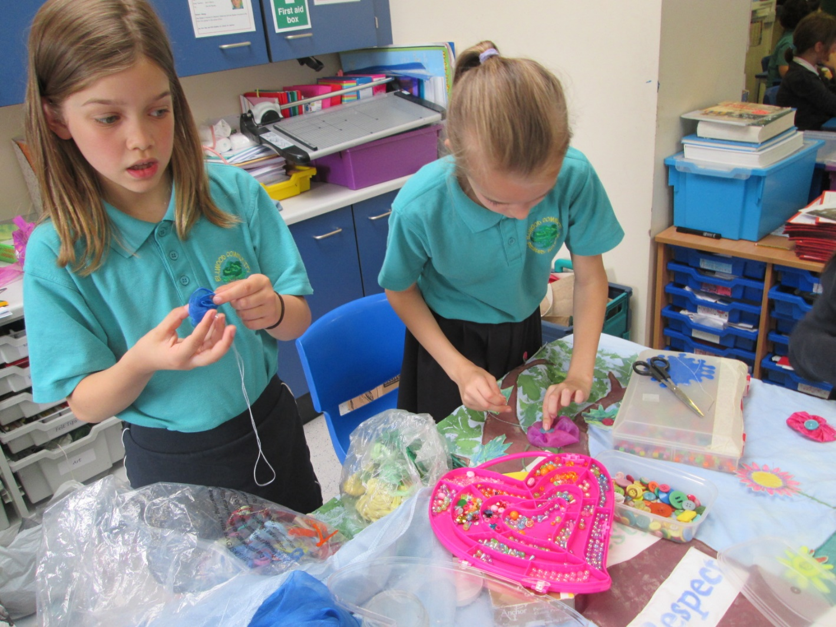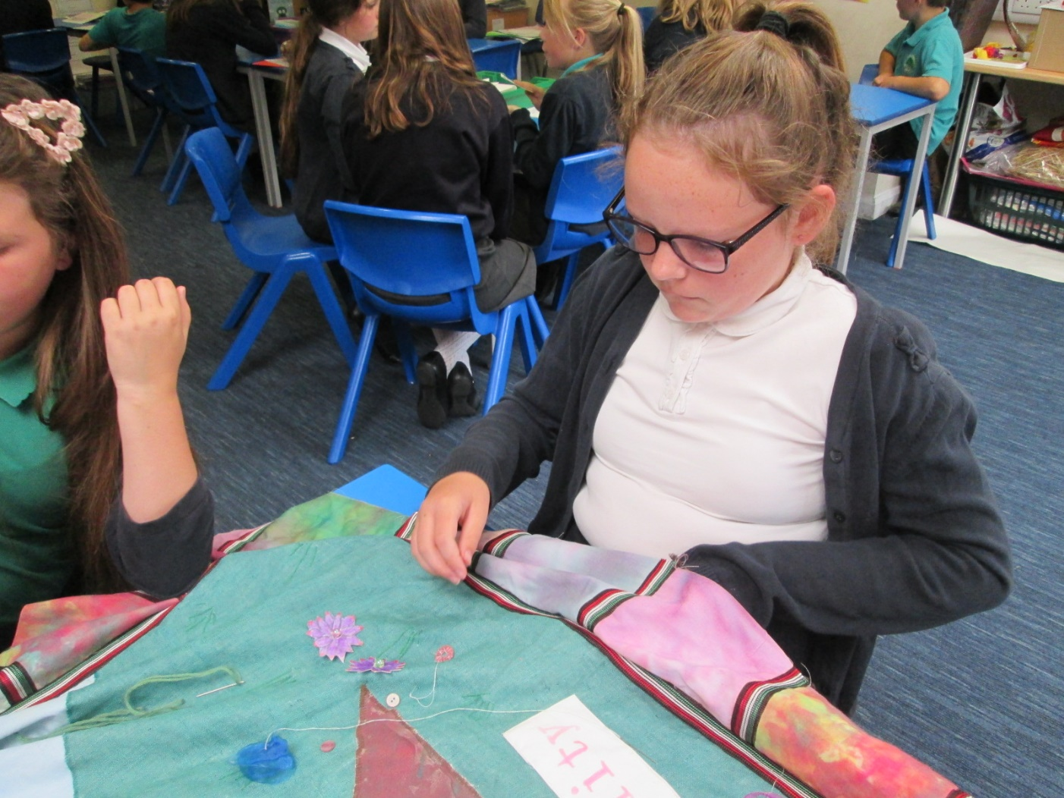

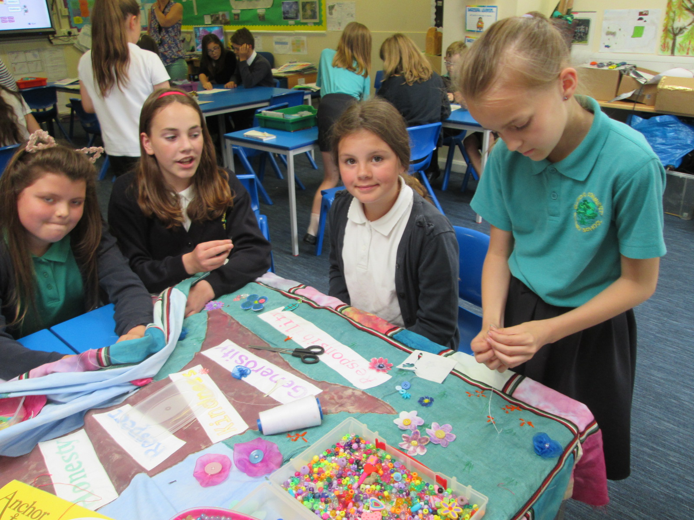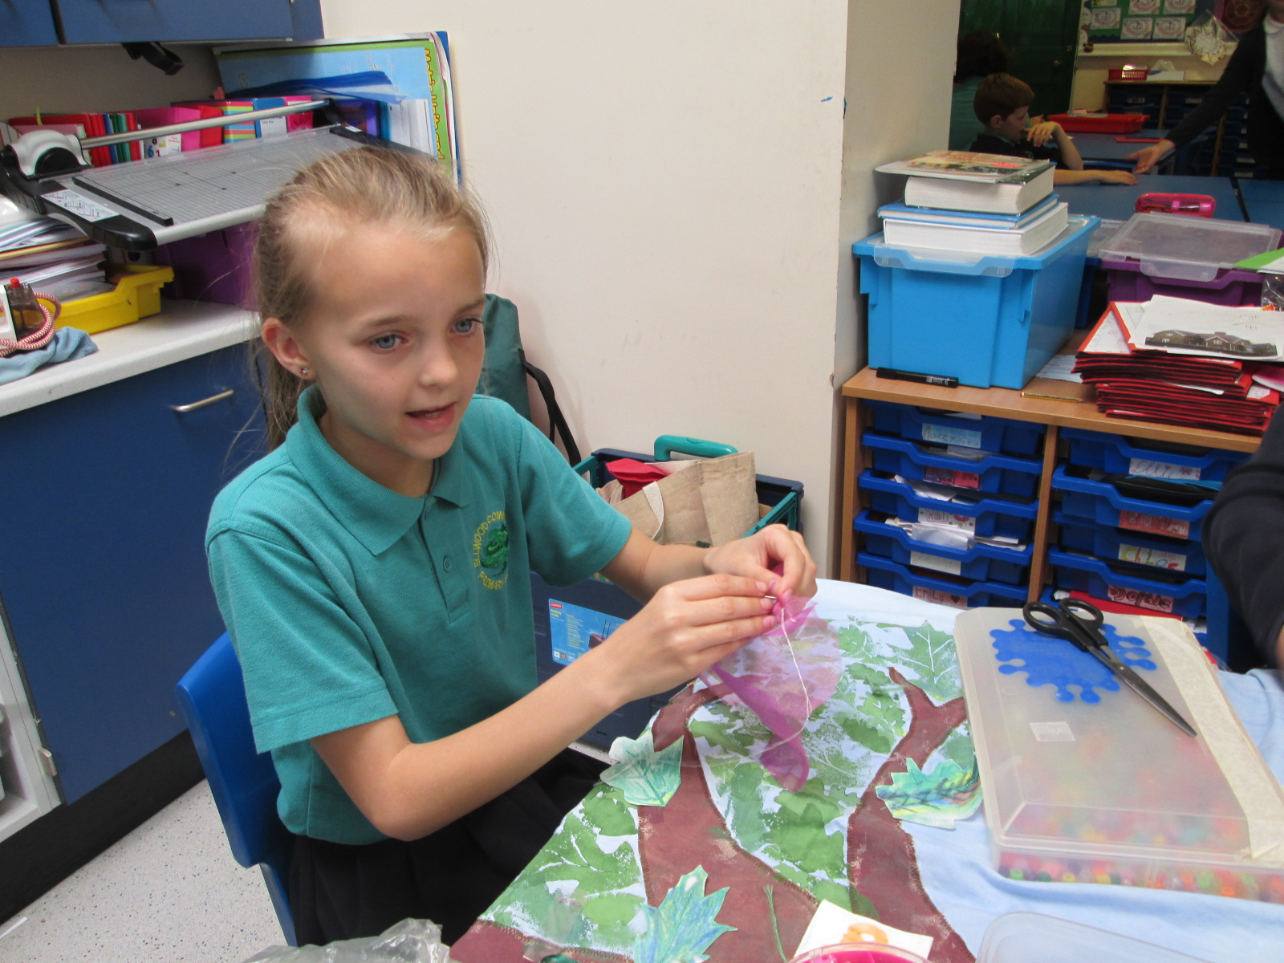

The final part was putting together all the flowers we had created and sewing on the stems. Our inner magpie emerged as we sewed on beads and buttons.

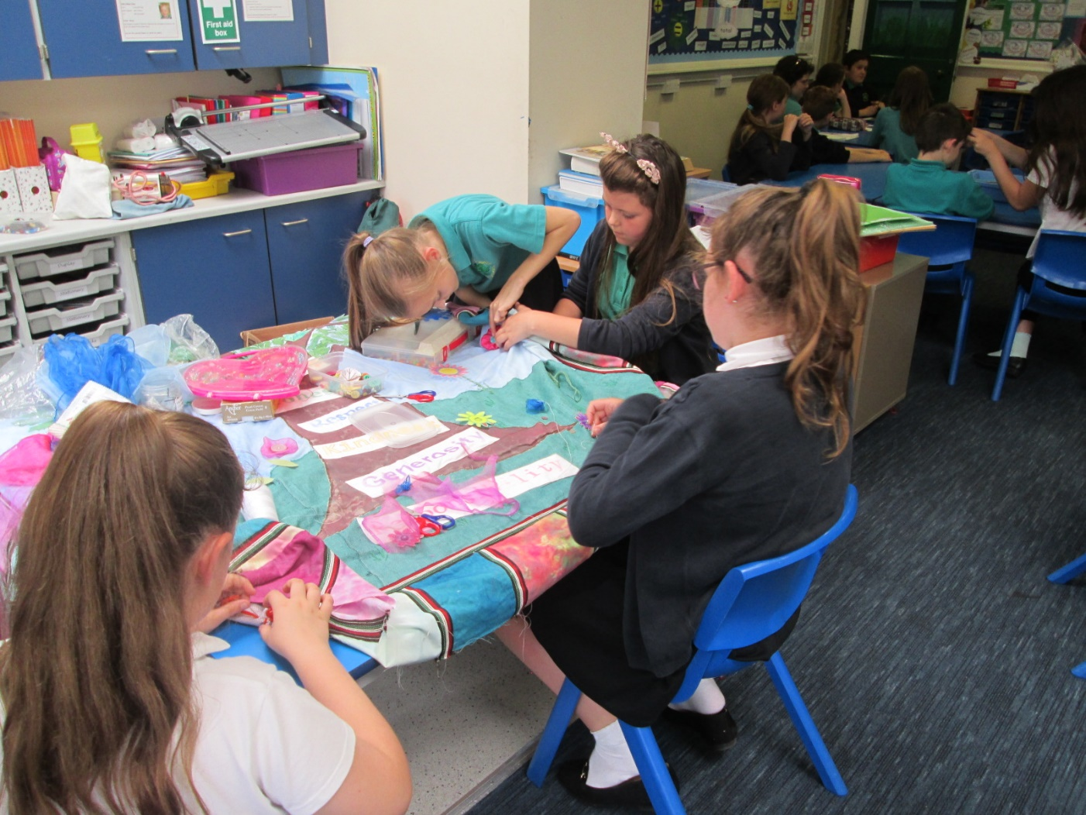

I enjoyed doing the sewing as I hadn’t done it before. (Ruby did many of the stems) I liked everything!

I liked making faces as you could have some fun with it and they didn’t have to look exactly like you.

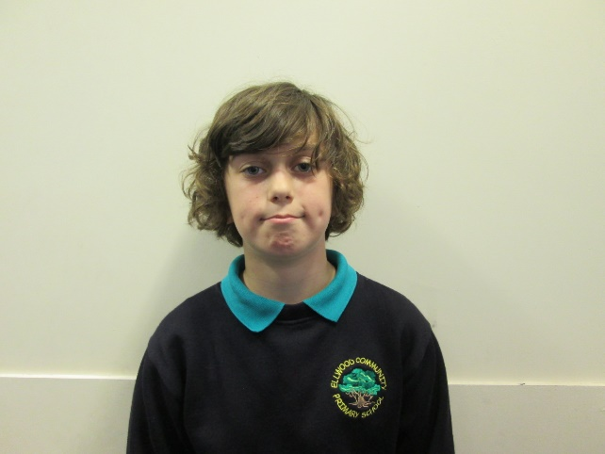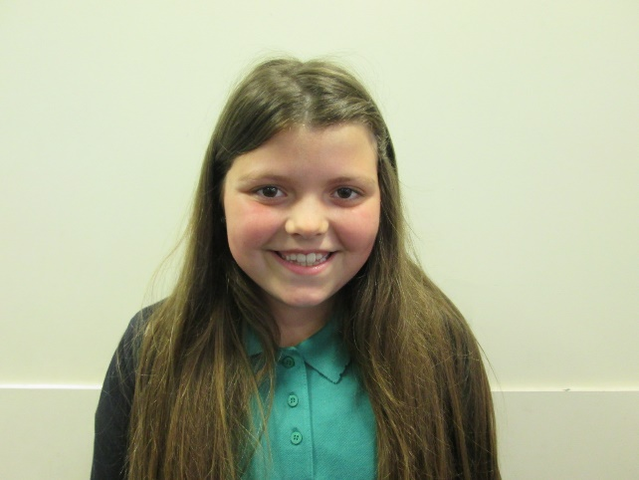

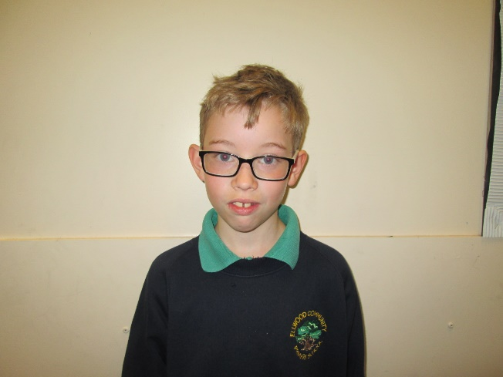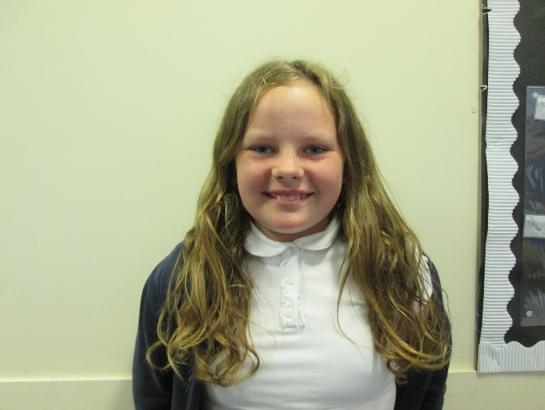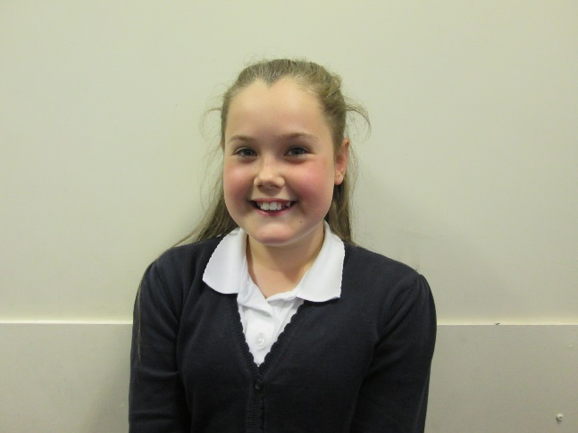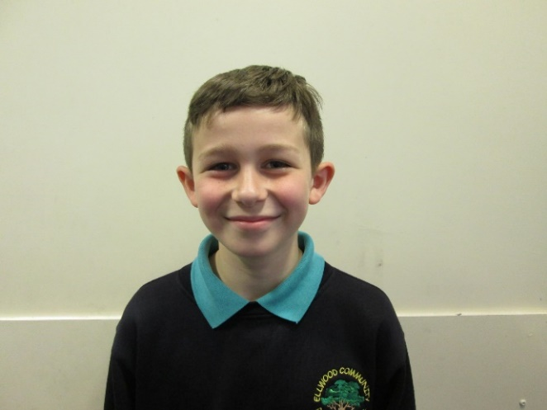

I liked making the pink flowers and sewing on the beads.

I liked making the faces because I’m really good at making things.

I liked making different shades of green when we printed the leaves

I didn’t think I could do anything but in the end I did and it was fun.

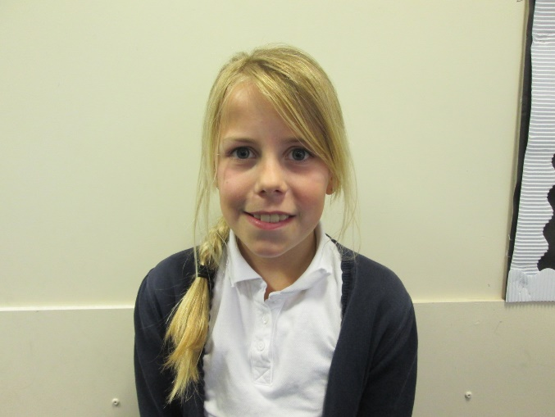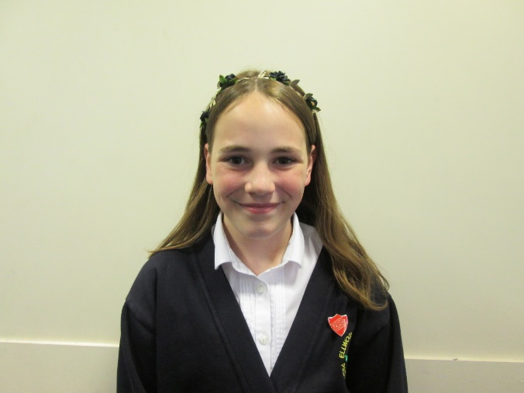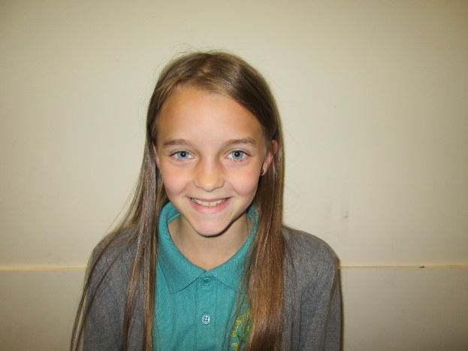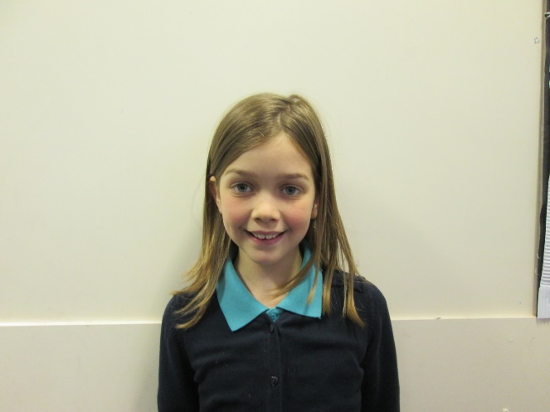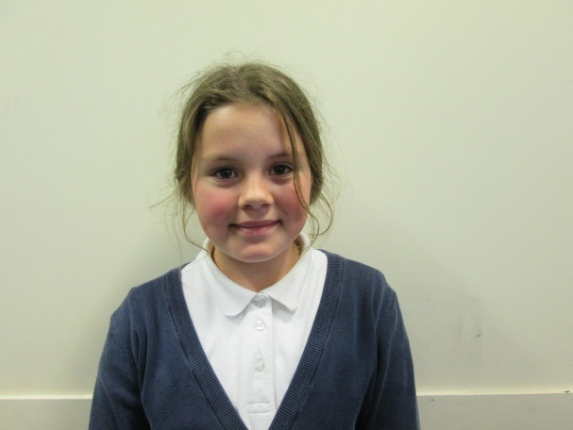

We had 5 fantastic afternoons printing, dying, sewing, drawing and learning new skills. There was a buzz of enjoyment with the project and we are all really proud of our finished hanging. Mrs Rees (Scroll down for the finished item.)

I liked using the transfer crayons to make flowers as I hadn’t done it before.

It was fun choosing all the different colours to do the tie dying.

I enjoyed seeing how well the leaf stamps worked. It looks really good.

I liked making the faces because I didn’t know that I was so good at running stitch!

I liked printed leaves and being creative.

