**History**

* Use sources of evidence to find out about the past
* Find out about the main events of World War 2
* Discover the Forest of Dean’s role during the War
* View local WW2 artefacts.
* Produce evacuee letters to loved ones.

**Art**

* Find out about famous WW2 artists
* Explore the art and sketching techniques of Henry Moore.
* Research and then create our own World War 2 medal.
* Create our own blitz art.

**D.T.**

* Make a model air raid shelter
* Investigate what was included within weekly ration books and create our own.
* Make and sample typical ration foods from WW2
* Create a gas mask box.

**English**

* Narrative writing based on Friend or Foe
* Class debates
* Non-narrative writing including – newspaper reports, diary entries, and letters
* War Poetry
* Presentations

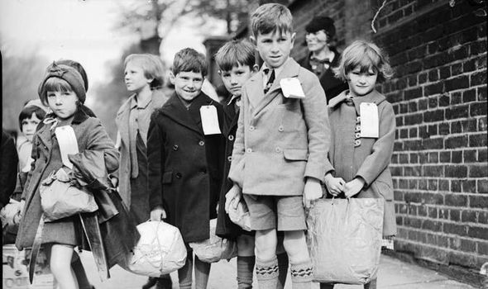

Fire, Fire!

**Geography**

* Investigate the role that the Forest of Dean had within WW2.
* Explore key memorabilia from the War.
* Research and map the countries that were involved within WW2