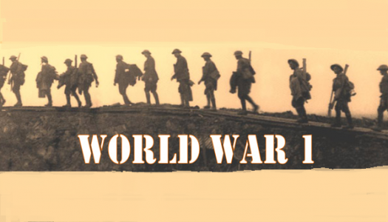

**English (Year 4)**

* We will be reading the books ‘Where the Poppies Now Grow’ by Hilary Robinson and ‘Paw Prints in the Somme’ by Dan Metcalf.
* We will be completing the following writing activities based on this book:
  + Character descriptions
  + Setting descriptions
  + Writing a narrative from a different point of view
  + Newspaper reports
  + Non-chronological reports
  + Diary entries
  + Letters

**Music**

* We will be reflecting on the history and background to World War 1 through music. We will be learning to sing in unison, explore rhythm, perform with instruments and develop original composing and creative music-making.

**Sycamore Topic Web – Pupil Overview**

**D and T**

* We will be learning to plan, design, create and evaluate a tank or battlefield transport for use of the Gloucestershire Regiment.

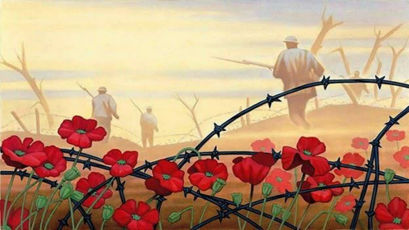

**Art**

* We will be learning to explore and discuss the work of the WW1 artists, create original pieces inspired by these artists and create artwork inspired by the poem ‘In Flanders’ Fields’. We will also be learning about the power and use of propaganda art.

**Physical Education**

* We will be creating and performing a dance which begins by learning the simple steps of a contemporary dance called 'The Castle Walk'. The movement sequences explore life working in a munitions factory on the home front.
* The dance will also explore trench warfare with a sequence about going 'over the top', Armistice and the commemoration of the War and those who died.

**History**

**We will be learning to:**

* investigate elements that led to the start of World War I
* explore the different sources showing what life was like at the Western Front and write a diary entry
* explore the different sources showing what life was like on the Home Front
* understand how armed forces personnel in wartime communicated with friends & family
* understand how personal communications were treated in wartime
* create and publish a newspaper to demonstrate how British armed forces communicated news and boosted morale
* understand what we can learn from our local war memorial
* understand Armistice Day and Remembrance
* the Christmas Truce

**Geography**

* We will be identifying countries who were involved in the First World War and researching these locations in Europe in further detail. We will be comparing maps of Europe from the 1900s to the map of Europe now.