History- Together we will find out what we already know about ‘Transport’ and what we would like to find out in this unit of work. The children will identify key events and people, develop an awareness of the past and sequence events in chronological order.

Transport

Geography – Human geography of Forest and Dean and the UK.

Seasonal and daily weather patterns in the UK.

RE – children will answer the question ‘Who is Jewish and how do they live?’

DT– design, build and evaluate a mode of transport e.g. bus, car

Music – listen to and respond to music.

Maths – We will be learning about place value to 50, addition and subtraction to 20, multiples of 2, 5 and 10. We will also be covering measurement – weight, height, volume and weight.

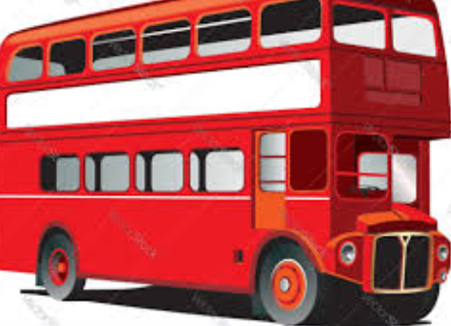

English – We will be using the book ‘The Naughty Bus’ as a stimulus where we will be retelling the story through actions and story maps. We will continue to develop our writing skills by using adjectives and verbs to make our sentences interesting.

Art – We will be looking at the work of Jackson Pollock and take inspiration to create artwork in a similar style.

Science – The children will learn the parts of the plants. We will also perform simple tests and observe how plants grow.